January 2012 Snowdances at U.S. Ski Areas
Documentation of Snow Blessings
Dawn of the New Era of SnowSports!

Vail Colorado (Combined with Ute Elders-led Gratitude Snowdances, prayers and ceremonies in Aspen, Telluride and Ski Sunlight)
The Ute Indian Tribe Performs A Snow Dance in Vail Colorado

(Video shows Eddie Box family of S. Utes leading Snowdance on 1/7/12, then powder skiing on 1/8/12)
http://www.youtube.com/watch?v=daj-uorWRuk&feature=related

Snow Job: Ski Resorts Call On Higher Authorities to Save Season

After a Native American Ceremony, Vail Gets Blanketed; 'Pray to Ullr'
By Ben Cohen | The Wall Street Journal Jan 20, 2012
Eddie Box Jr. is a 66-year-old member of the Southern Ute Indian Tribe of Colorado who hasn't skied in 40 years. Yet he wasn't entirely surprised when he received an unusual invitation this month from a Vail Resorts representative.
Once again, Mr. Box was being asked by executives at the country's skiing mecca to perform a snow dance.
Mountain resorts across the U.S. are desperate for fresh powder. For the first time since the 1800s, Lake Tahoe received no December snow. Peaks in the Northeast saw rain. Vail Resorts recently reported a 15% decrease in total skier visits at its six properties, and not for 30 years have Vail Mountain's back bowls, perhaps the most prized terrain in the country, been roped off so late in the season for lack of snow.

[More from WSJ.com: Watch Video of the Snow Dance]

But on Thursday, Vail's bowls finally opened, thanks to 25 inches of snow that has fallen since Mr. Box's snow dance on Jan. 7. The day of the ceremony "really feels like it was a big change in the weather pattern," said Chris Jarnot, Vail Mountain's chief operating officer.
Some winter tourism hubs are parrying the peculiar La Niña weather in unconventional ways. Big Sky Resort in Montana is honoring season lift tickets from its competitor Vail Resorts, provided tourists purchase certain lodging. A whiteboard at the top of Vail's Northwoods Express chairlift recently read, "Pray to Ullr for snow," referring to the Norse winter god. About an hour away, Breckenridge Ski Resort was in the middle of its annual Ullr Fest, a Viking-themed celebration.
Then there was Vail's approach.
On the morning that Mr. Box led one of a handful of snow dances in Vail's history, his grandson woke him by noticing flurries outside the Lodge at Vail, their ritzy hotel at the mountain's base.
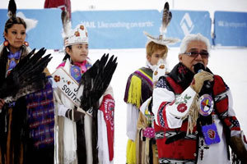
Eddie Box Jr., right, of the Southern Ute Indian Tribe performed a snow dance at Vail Mountain on Jan. 7. When the tribal elder arrived at Vista Bahn Express—the same chairlift where he watched his father, Eddie Box Sr., offer Vail's first snow dance in 1963—his hands were cold with wet flakes. By the time lifts closed for the evening, the mountain was coated with eight inches of snow.
Three days of blue skies and balmy temperatures melted the offering—but not for long. Vail reported six inches amid whiteout conditions Jan. 11. Another 10 inches arrived Monday. The forecast this week projects more snow.

It seemed that Mr. Box's meditation for "moisture from Mother Earth" had worked. "It's not only for the snow," Mr. Box said. "When the water starts running off the mountain, and the flowers and every little thing starts growing, it benefits all humans."
A week after Vail's snow dance, Park City Mountain Resort in Utah invited about 30 Northern Utes to a plaza near its base for a mountain blessing at high noon. Park City had reached out to them around Christmas. "We felt like it was time for Mother Nature to kick in," said Park City marketing director Krista Parry, as she watched five inches of snow drop outside her window Wednesday.

Last Sunday, descendants of multiple Native American tribes presented their own snow dance at a state park near Lake Tahoe's skiing areas. Forecasts for Northern California now predict enough snow to salvage the season's dismal opening.
Snow dances aren't as common in Native American culture as sun dances or rain dances. But they are guided by the same principles.
"It's not done every year," said Majel Boxer, a Native American studies professor at Fort Lewis College in Durango, Colo. "That would not be in keeping with the idea that you only ask when you're in great need."
The West isn't the only area lacking this season. With the exception of a rare October snowstorm in the Northeast, slopes in the region weren't pelted with snow until this month. "Most storms have been wet, not white," said National Weather Service spokesman Chris Vaccaro.

Okemo Mountain Resort in Vermont hasn't seen a winter quite like this in about 30 years, said Bonnie MacPherson, the mountain's director of public relations, who sent a videographer onto the slopes before Christmas to ask skiers to show off their best snow dances.
As of Dec. 27, the weather service says 24.3% of the country was covered in snowfall, compared to 54.5% a year earlier. Recent snows have improved that number; as of Jan. 19, 34.4% of the country was covered.
In Colorado, conditions on New Year's Day were the driest since 2002, according to the National Resources Conservation Service. Mr. Box received an email from Vail on Jan. 2. The Southern Utes had been to Vail before, including in 1999, the year the mountain hosted the Alpine World Ski Championships.
"We would love to celebrate the Native history of the area, and hopefully help put an end to our ongoing drought of snow," the email read. Mr. Box chose Jan. 7. The weekly forecast then called for more dry weather. Immediately he incorporated requests for precipitation into his daily prayers and sweat-lodge ceremonies.
In Vail, he began the ritual at 8:30 a.m. Snow showers already swirled around a few hundred spectators. In the colorful regalia he might wear to a powwow, Mr. Box danced to the rhythm of hums, drums and an eagle-bone whistle. He also led what he called a "friendship dance," in which skiers and onlookers joined hands and moved in a circle.
Vail promoted the event using Twitter and Facebook, but not through advertisements or media invitations. The resort covered Mr. Box's expenses and lodging while he was in town. Mr. Box says he doesn't accept money for snow dances.
Before closing, Mr. Box presented Mr. Jarnot, the COO, with a package of tobacco and asked that he find a special place on the mountain and sprinkle it in all four directions.
Mr. Jarnot and three others rode up to a run that overlooks the back bowls. They skied down a trail, clicked out of their skis and hiked five minutes to a secluded location. "We took a little moment to make our offering and show respect," Mr. Jarnot said. "Then we snapped our skis back on and skied down."
It was snowing so fiercely by then that Mr. Box's wife, Betty, had convinced him to drive home to beat the storm. "My honey said, 'We have to get out of here before it gets really bad,'" Mr. Box recalled. "We had to four-wheel it."

Link for: Ski Resorts Call On Higher Authorities to Save Season After a Native American Ceremony, Vail Gets Blanketed; 'Pray to Ullr' http://finance.yahoo.com/news/snow-job--ski-resorts-call-on-higher-authorities-to-save-season.html
WSJ: Youtube of Ute Snowdance at Vail: http://online.wsj.com/public/page/0_0_WP_3001.html?currentPlayingLocation=NaN&currentlyPlayingCollection=Lifestyle&currentlyPlayingVideoId={D56064E6-D083-48A4-818E-8CD657396060}
SIA Reprinted Vail Business Journal story:

Suzy Chaffee: Snowdancers have much to do with recent blessing of precip
Former Olympian, a.k.a. Suzy Chapstick, says Vail may do well to pay it forward
January 10, 2012, 9:23 am
By Tara Flanagan
The Vail & Aspen Business Journal (also reprinted in SIA’s on line “Latest”)
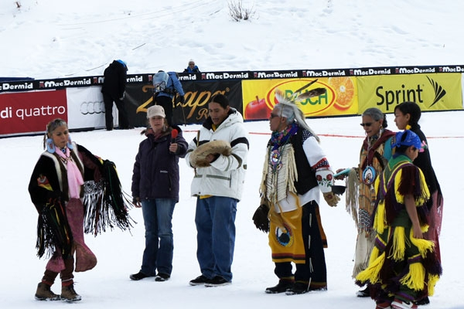
photo courtesy of Vail Foundation
Eddy and Betty Box and Southern Ute dancers perform a Gratitude Snowdance and blessing of the athletes to open Vail's 2010 World Cup, hosted by Vail Academy.
VAIL, Colo.—There was a collective sigh of relief through Colorado’s central mountains Sunday morning as the day broke into a robin’s-egg-blue sky and a blanket of priceless snow swathed the earth and trees.
The storm broke a spell that had been Vail’s driest in 30 years, dumping eight inches at Vail, nine at Beaver Creek, seven at Breckenridge and six inches at Steamboat. Some forecasts call for more snow mid-week.
True, sooner or later, it’s going to snow. But with the ski season moving toward mid-January and with that, the holiday and winter break reservations running their course, it was perhaps time to summon help on a level beyond “sooner or later.” And in the meantime, Vail did some returning to its roots.
Enter Southern Ute elder Eddie Box Jr., his wife, Navajo elder Betty, and an entourage of snow dancers. At the behest of Vail Resorts brass, they performed a blessing at the base of the Vista Bahn Saturday morning amid a couple hundred onlookers, some who joined in chanting. As the dance continued, the snow thickened in the sky. The mood, reflected on Facebook and Twitter, was primarily one of awe and thanks, and the skeptics were staying quiet.
If you were alive during the days of, say, leather ski boots, you may recall the do-or-die winter of 1962-63, when the fledgling Vail had to change up its lack of snow or face extinction. Summoned by Vail’s founders, who were humbled at the prospect of no snow, Eddie Box Sr. and a group of Utes arrived on the scene to dance, and within two days, the snows began – with national news coverage. The Utes have made rare appearances in Vail over the years, with a dance for the 2010 World Cup and their most recent foray on Saturday.
You also may recall Suzy “Chapstick” Chaffee, whose career has evolved from Olympic downhiller to world champion freestyler and model-esque lip-balm spokesperson, to her current incarnation as co-chair of the Native American Olympic team Foundation (formerly Native Voices Foundation). The group works to strengthen cross-cultural bonds and bring native kids to the world of skiing and snowboarding on their ancestral lands.
Chaffee lives in Puerto Villarta, Mexico now. Having lived in Aspen and Telluride over the years, she still keeps tabs on Colorado’s weather -- even though her philosophies about it lean away from the scientific grid.
Chaffee says there is much between the native spiritual world, the weather, the global state of affairs and the Mayan calendar leading to December 2012. She says when the Utes danced on Saturday, they brought healing to the entire region. Not just in the form of snow, but also cleansing the dark energies brought by accidents, pollution and other bad circumstances.
“This year is called The Purification by the tribes,” she says. “Mother Earth is purifying the planet. It happens every 26,000 years… this is the year to wake up.” In other words, she says it’s best that people get wise now and settle their karmic debt.
After the U.N.“Following the U.N. initiating International Mother Earth Day two years ago, where 192 countries recognized her as a living, loving, wise, very compassionate being, the U.N. sustainability officer heard about the snowdance phenomena at U.S. Ski Areas,” she says. “Because the gratitude snowdances wake up ski resorts to realize, like I did, that Mother Earth listens, they asked us spread this story to inspire communities worldwide to follow our lead.”
She lauds Vail for pioneering the snowdance among ski areas. “Even though these lands were taken from the Utes, Eddie Box Sr. and Jr. have led these ceremonies in Vail and elsewhere to create harmony between our cultures and Mother Earth,” she says. “Healing takes place when ski communities honor their tribal gifts and invite tribal youth back to their ancestral lands.”
She shared that on Jan. 5, “Billy Kidd of Steamboat called and said, ‘This is the first year we haven’t been inundated by snow -- can you help us find someone to lead a snowdance here?’” Eddy and Betty Box had been booked for Vail, it turned out, but said they would be sure to pray for the surrounding region.
It indeed snowed at Steamboat.
She also says the gratitude dances can set up an entire weather system, and that there are past performances to back her claims. There was the original Vail blessing. There was also the Kansas drought of 1996, in which farmers summoned the natives for help, with rains following soon thereafter. There were the 2004 dances at ski shows, which coincided with an end to droughts at California’s ski areas. As well, Chaffee says Europe saw snow after a severe warm stretch in 2007. In that case, a prayer ceremony originated at California’s Mount Shasta and was sent around the world.
But Chaffee says the blessings run both ways, and that she’d like to see more support in the form of affordable ski privileges and programs for Native American kids. Her own interest in Native American causes was accelerated in the mid-1990s, when she moved to Telluride and helped establish the first native ski program there. Today, native kids can ski for $15 there, with ski shops such as Christy Sports and Bootdoctors donating gear.
As a former crusader for women’s equality in sports, she believes that fitness and competition can lift up the underserved and under-recognized. Telluride, where she lived for five years, is a good example of a ski area that has forged a strong partnership with the natives, she says, adding that Billy Kidd (of native descent) has embraced the cause at Steamboat with the Ute Future Olympians program.
Chaffee points to diabetes and other health issues that run rampant in the Indian youth. “A program like this turns youth into lean and clean, diabetes-free, happy kids who have a relationship outside the reservation for things like job opportunities,” she points out. “And in turn, the ski areas get the wisdom of the tribes and their elders.”
As she said, Chaffee is glad Vail came to the fore in the 1960s and established a new bond with the Utes. But she thinks Vail Resorts could cover more ground in the form of programs for native children. She says Denver could provide a steady flow of participants, and in exchange, there would be continued blessings for the region.
She envisions a scenario “so that everybody’s having fun… that we’re healing hearts.
“We’re all part of Mother Earth together,” she says.

Outdoors 720

An outdoors blog about all things outdoors...

Friday, January 20, 2012

(http://www.outdoors720.com/2012/01/vail-resorts-to-snow-dance-lake-tahoe.html)

Vail resorts to snow dance; Lake Tahoe ski resorts could use one, too
Lake Tahoe ski resorts, take note.
If you are lacking in snow for the winter sports season, as the ski resorts in the Lake Tahoe region are, invite a Native American to do a snow dance.
Are you listening, Squaw Valley? Northstar-at-Tahoe? Heavenly? Alpine Meadows?
Look what happened at Vail Ski Resort in Colorado.
Vail was reporting a 15 percent decrease in total skier visits at its six properties, and Vail’s popular back bowls had been roped off late into the season because of a lack of snow, according to The Wall Street Journal.
So what did Vail do?
It asked Eddie Box Jr., 66, a member of the Southern Ute Indian Tribe of Colorado, to lead a snow dance, much to the delight of skiers and snowboarders.
Here’s how it went: (See WSJ video above)
Since the snow dance was performed on Jan. 7, Vail has received at least 25 inches of snow, and the back bowls opened Thursday for the first time this ski season, the WSJ reported.
Apparently, this wasn’t the first time Vail brought in a Native American to perform a snow dance. Box’s father performed the first snow dance at Vail in 1963. By the end of that day, the mountain was covered with eight inches of snow.
Like other mountain resorts across the U.S., Lake Tahoe resorts are starving for fresh powder for the skiing and snowboarding season. The region just recently broke a record of 56 straight dry days, including a completely dry December. Can you say snow dancer?
Ah, but finally on Friday, the Tahoe resorts were starting to get some snow, according to Ski Lake Tahoe.
But if the Tahoe ski resorts really want a good dumping of fresh powder, they might want to call Vail to get the phone number for Box.
A snow dance sure couldn’t hurt.

Sign Up

The Southern Utes Snow Dance Works Wonders on Weather
By ICTMN Staff January 13, 2012 reprint courtesy of Indian Country Today Media Network

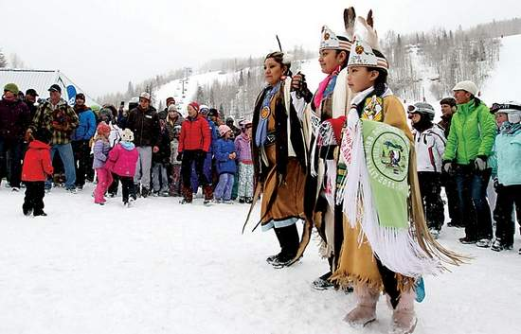
Dominique Taylor/Vail Daily
Southern Ute Indian royalty, Little Miss Southern Ute Alternate, Yllana Chanelle Howe, 7, right center, Junior Miss Southern Ute, Izabella "Oewichichi" Howe, 10, center, and their mother, Marquetta Howe, left, help lead the crowd in a Southern Ute snow dance Saturday at the base of the Vista bahn chair lift in Vail Village. Yllana's Ute name is "Nanacivchi" meaning butterfly while Izabella's Ute name is "Oewichichi" meaning Yellow Bird.
In Vail, Colorado, members of the Southern Ute Indian tribe gathered this past Saturday at the base of the Vista bahn chair life in Vail Village. The mountain, like many resorts in the area, was having a little problem—a lack of snow.
There at the base of the lift, Southern Ute royalty Little Miss Southern Ute Alternate, Yllana Chanelle Howe, 7, Junior Miss Southern Ute, Izabella “Oewichichi” Howe, 10, and their mother, Marquettea Howe, helped lead a crowd of hundreds in a Southern Ute snow dance. Those gathered around couldn’t ignore the fact that, as the Southern Utes performed their ritual, the snow fall increased.
“It appears to be working,” Vail Mountain Marketing Director Adam Sutner told Vail Daily.
Vail Daily reported that this was only the third time in the resort’s 49-year history that they were privileged with the Southern Ute Indian Tribe’s performance of this prayer. Two tribe members, Eddie Box Jr. and his wife Betty, who were present at the prayer, had been to Vail Mountain before. Box first came in 1962, the resort’s inaugural year, and performed the dance with his father, Eddie Box Sr.
When Vail Mountain opened in 1962, they found the first year of their operation wasn’t going according to plan—the snow wasn’t falling. So they called on the oldest continuous residents of Colorado, the Southern Utes, to come to the mountain and perform a prayer.
Sunter told Vail Daily that after the Southern Utes performed the snow dance that first year, the snow fell, and fell, and fell. So this season, which has gotten off to a very dry start, Vail Mountain officials thought they should better contact the Southern Ute Indian tribe again. So they came, and so did the snow.
The last time the dance was performed was in 1999, when the mountain was hosting the World Alpine Ski Championships.
Wouldn’t you know…that year saw a lot of snow.
http://indiancountrytodaymedianetwork.com/2012/01/13/the-southern-utes-snow-dance-works-wonders-on-weather-72125

Park City Utah
Washington Post Lifestyles (front page) Jan 14, 2012
Resort hopes Native American blessing brings snow

http://www.washingtonpost.com/newssearch/search.html?st=january+20+Park+City+gets+snow&fn=&sfn=&sa=&cp=1&hl=true&sb=-1&sd=&ed=&blt=&bln=&dpp=10&df=Past+7+Days (All the Wash Post Google links no longer open, but it looks like the same story and photos at AP’s since the title was the same)

By Lynn DeBruin
The Associated Press

Sat, 01/14/2012 - 10:42pm
Copyright 2012 The Associated Press. All rights reserved. This material may not be published, broadcast, rewritten or redistributed. Reprinted with permission of the Associated Press 2012
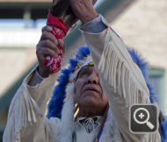

PARK CITY — Some have danced for rain.
In Utah and other parts of the West, it’s all about the white stuff.
It’s why officials at Park City Mountain Resort brought in members of the Northern Ute Tribe to perform a snow blessing.
On Saturday, they prayed, danced and chanted as hundreds of helmet-clad skiers and boarders watched and hoped the ritual would elicit more cooperation from Mother Nature.
A similar gathering in California was planned for Sunday at Lake Tahoe with dancers from the Paiute, Shoshone and Washoe tribes.
If ever there was a year it is needed, this is it.
December was among the driest on record in Northern California. The California Department of Water Resources reported the snowpack water content throughout the Sierra Nevada at 19 percent of the average for early January.
In Utah, snow levels are less than 50 percent of average.
Park City has been forced to make 40 percent more snow than at this time last year.
“Our snowmakers have been working around the clock, so we said it is time to put in a call to Mother Nature,” said Krista Parry, marketing director at Park City Mountain Resort.
She also called on a friend, Frank Arrowchis, who led a similar ceremony at Arches National Park to bless the Olympic Flame during the torch relay in 2002.
Arrowchis led the prayer Saturday in English, followed by one in Ute by Spiritual Leader Albert Lance Manning.
“We hope our prayers are answered because it’s for everybody,” Arrowchis said. “Prayer has a lot of power if it’s done right. We hope we do get some snow. If we don’t, we tried.”
Forecasters say good news may be on the way as a new storm pattern is emerging that could start dumping snow in Utah and the rest of the West next week.
Brian McInerney, a hydrologist with the National Weather Service in Salt Lake city, said the high pressure ridge that has dominated since mid-November is disappearing.
That will allow storms to track in from the West again.
He said the jet stream, as it is currently tracking, may push much of the moisture about 100 miles north of Salt Lake City.
“But if the storm track goes down a little south, we could be in for lot of snow starting next Wednesday, with most precipitation coming by the weekend,” McInerney said. “The key is the high pressure is breaking down and opening the door for storm activity.”
On Saturday, the temperature in Park City was 43 degrees at noon, with joggers in shorts and not a cloud in the sky.
The temperature reading was about twice as high as the base in many areas, though Alta, Snowbird and Brighton were reporting 37-inch bases.
At this time last year Park City had a 77-inch base with 112 of 114 runs open and every lift operating. On Saturday it had only 58 runs open and three lifts still closed.
McInerney said a weather service recording station inside Park City indicates it has received 5 inches of snow-water equivalent this season, 42 percent of normal and less than a third what the resort had at this time last year.
The lack of snow has sparked plenty of rumors that some resorts in Utah — particularly Canyons — might be closing for several weeks.
Nathan Rafferty, president of Ski Utah, said those rumors are false.
“I’m not going to blow smoke and tell you it is what it was last year,” he said. “But the snow from Mother Nature and what resorts (produce) have made for skiing that’s a lot better than you think.”
Just don’t tell a powder-hound, or as Rafferty says, “spoiled locals dying to get out and ski some powder.”
“It’s one thing if you’re from Salt Lake City or a Utah local and are used to big powder days,” Rafferty said.
“It’s another to be a family from Cincinnati, Ohio, absolutely thrilled to be on an intermediate and beginner slope under blue skies and warm temperatures. The destination skiers who bring a good chunk of money to the state are pretty thrilled.”
Still, Mike Larsen, 39 of Alpine, who was skiing Saturday with his son, Davis, can’t forget last year.
There was so much snow under one lift the resort had to close the run because it was too high. Now the run has more rocks than snow.
“I’m hoping for a lot better snow,” Larsen said. “But it’s kind of a tradeoff. You get beautiful bright sunny days like this.... But last year was unbelievable.”
http://news.yahoo.com/resort-hopes-native-american-blessing-brings-snow-224114022.html

Snowball Effect: Ski Resorts Seek American Indian Help Bringing Snow

By ICTMN Staff January 18, 2012 reprint courtesy of Indian Country Today Media Network
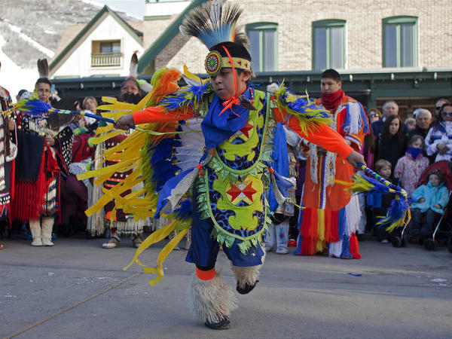
AP Photo/Jim Urquhart
Beltran Burson, 8, of the Native American Northern Ute Tribe dances as part of blessing for more snow at Park City Mountain Resort in Park City, Utah, Saturday, Jan. 14, 2012
Get News Alerts

First, we told you about how the Southern Ute Indian Tribe were called, yet again, to help the Vail Mountain ski resort get some snow. The tribe performed their Snow Dance, a ritual they have been brought in to do in previous, snow-poor years. The snow fell, and kept falling, while the Southern Utes danced. Now, officials other big time ski resorts, in Utah and California, are hoping for the same results from American Indian tribes in their areas.
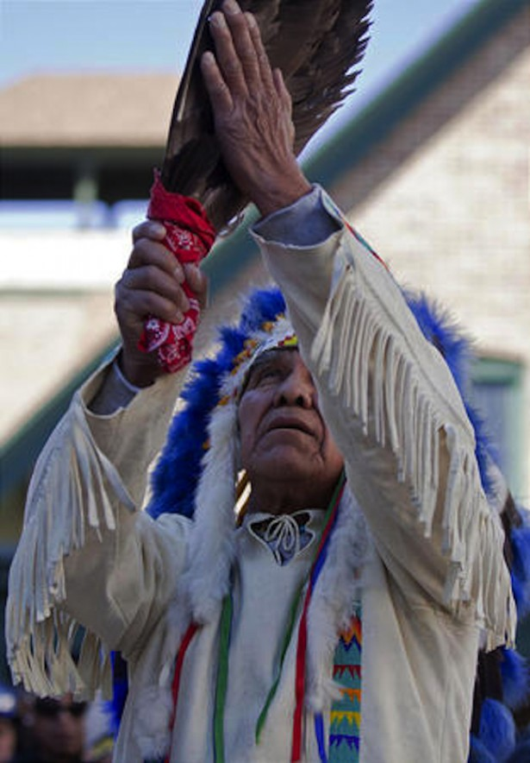
Frank Arrowchis, Northern Ute Tribe, performs a snow blessing at Park City Mountain Resort in Park City, Utah

Park City Mountain Resort in Utah, brought in members from the Northern Ute Tribe to perform a snow blessing, reported Deseret News. This past Saturday, the tribe came to the mountain to do their best to end the snow drought while hundreds of skiers watched in awe.
Ski resorts around the country have had to rely on their snowmakers for much of their snow as snowfall levels are less than 50% of their average in Utah. ”Our snowmakers have been working around the clock, so we said it is time to put in a call to Mother Nature,” said Krista Parry to Deseret News, the marketing director at Park City Mountain Resort. Parry is friends with Frank Arrowchis, a member of the Northern Ute Indian Tribe who also blessed the Olympic Flame during the torch relay in the 2002 Winter Olympics in Salt Lake City. Arrowchis led the prayer this past Saturday in English, with Ute spiritual leader Albert Lance Manning following it in the Ute language.
“We hope our prayers are answered because it’s for everybody,” Arrowchis told Deseret News. “Prayer has a lot of power if it’s done right. We hope we do get some snow. If we don’t, we tried.” Forecasts seem to be showing very good news—a new storm pattern is emerging that could start blanketing Utah in snow and then on the rest of the West in the coming week.
Over in the Sierra Nevada mountains of California, similar gatherings took place in Lake Tahoe, with members from the Paiute, Shoshone and Washoe tribes coming to Sugar Pine Point California State Park to take part in a ritual known as the “Round Dance.” Now, the forecast in Tahoe since the ritual took place shows a big break in the extremely dry weather that has plagued the area since early December, as snow is predicted to start falling today, according to EatDrinkExplore.com.
On Martin Luther King Day, the Northern Utes blessed the slopes of Sunlight Mountain Resort, in Glenwood Springs, Colorado. According to OnTheSnow.com, the Northern Utes have been coming to Sunlight for many years. This started when Olympians Billy Kidd, Abenaki, and Suzy Chaffee, co-founder of Native Voices Foundation (renamed the Native American Olympic Team F0undation) based in Aspen, originally organized an event for the tribe to come to the mountain.
“The Ute Indians have been coming to Sunlight for many years and we welcome them every time as they bring the mountain great greetings and hopeful snow,” said Jennie Spillane, an employee of Sunlight, to OnTheSnow.com
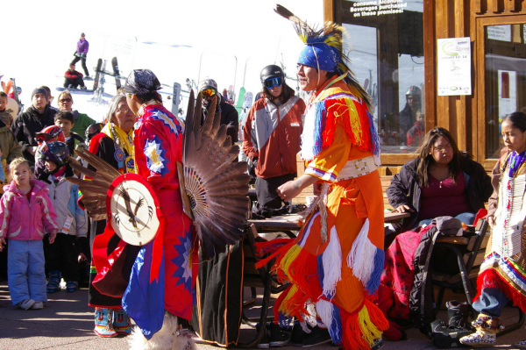
The Northern Utes have been coming to Sunlight Mountain Resort for years
http://indiancountrytodaymedianetwork.com/2012/01/18/snowball-effect-ski-resorts-seek-american-indian-help-bringing-snow-72702#ixzz1k4uy2aub

Scott Ford's videos
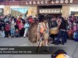
Ute Indians Snow Prayer and Dance at Park City last Saturday.
Excellent 20 minute video of the whole ceremony with dancing by Scott Ford http://vimeo.com/35119917
On Saturday January 14th, 2012; The Ute Indians came up to Park City and preformed a prayer and snow dance at the Park City Mountain Resort. It was amazing! They performed on the main level in front of Cole Sport Bazookas, next to the ticket windows. The video is 20 minutes but worth it. It starts with the prayers and moves to the dancing. I hope the video captures a small piece of how intense it was.

It worked!
By parkcitynews
Jan 19, 2012 http://www.standard.net/stories/2012/01/14/resort-hopes-native-american-blessing-brings-snow
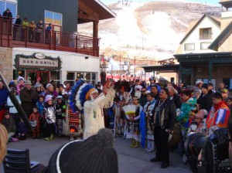
This past Saturday, in pulling out all the stops, Park City Mountain Resort invited the Ute Indian tribe to come out and perform a traditional offering to Mother Earth and a snow dance. This was really quite an event, held on the Plaza of Park City Resort, where about 15-20 Ute Indians in full traditional garb performed a snow dance to encourage snow. Well, it worked as yesterday was cold and snowy and the forecast is for heavy snow Wednesday and every day going into next week. Finally! Of course it always help to schedule a snow dance when the forecast calls for snow. Tends to make the dance more successful and everybody feel better about it. But still with this winter even with a forecast for snow there's no sense in taking any chances.

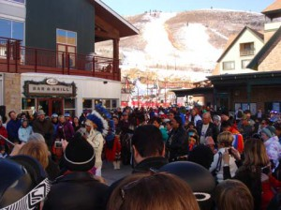
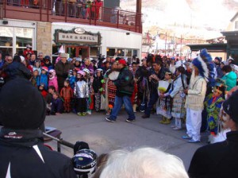

Snow boosts spirits at Sierra ski resorts
By MARTIN GRIFFITH, Associated Press
Sunday, January 22, 2012 Reprinted with permission of the Associated Press 2012

(01-22) 18:34 PST Reno, Nev. (AP) --
A string of storms has brought something Sierra Nevada ski resorts haven't seen much this season: snow.
Lake Tahoe resorts, which have been relying on snow-making machines to stay open, reported the storms have dropped 1 to 2 feet of snow since Thursday. Another storm was expected to dump from 15 to 30 inches overnight at higher elevations around the Tahoe basin by Monday afternoon, according to the National Weather Service.
"It's great to have Mother Nature lending a hand," said Andy Chapman of the North Lake Tahoe Resort Association.
Despite the new snow, Sierra ski resorts still offered limited operations. The Tahoe basin snowpack was only 25 percent of normal for the date.
Around Tahoe, eight of 170 runs were open at Squaw Valley, five of 100 trails were open at Alpine Meadows and 32 of 97 trails were open at Heavenly. Farther to the south, Mammoth Mountain reported 51 of 150 runs open, while Kirkwood said six of 72 trails were open.
Jon Slaughter, spokesman for the Boreal resort atop Donner Summit, said he hoped Monday's storm would allow more terrain to open. Boreal reported 12 of 41 runs open on Sunday.
"I'm thrilled to see we actually have some natural snowfall," Slaughter said. "We're going to be able to rapidly expand the terrain. We should be able to groom more runs."
The storms came less than a week after a group of Paiute, Shoshone and Washoe tribal members performed a traditional ceremony seeking spiritual help to bring snow to the Sierra. Some 200 people took part on Jan. 15 at Homewood on Tahoe's west shore.
The current skiing and snowboarding season stands in marked contrast with last season, when roughly twice as much snow as normal fell in the Sierra and resorts stayed open later than usual to take advantage.
http://www.sfgate.com/cgi-bin/article.cgi?f=/n/a/2012/01/22/state/n171702S64.DTL#ixzz1kH5cgkuh
Monday, January 16, 2012 Sierra Sun.
Native American dance brings snow to Tahoe
By Pettit Gilwee
Special to the Sun 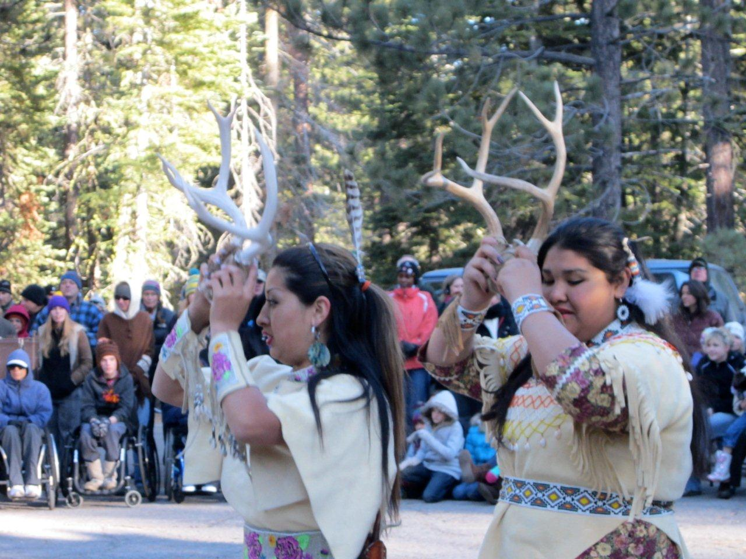
The Eagle Wings Dance Group, descendants of the Paiute, Shoshone and Washoe Tribes from Reno Sparks Indian Colony offered traditional songs and sacred dances as part of the Closing Ceremonies for Olympic Heritage Celebration Week on Sunday at Ed Z'berg Sugar Pine Point State Park.
Carolyn O'Connor / Sierra Sun
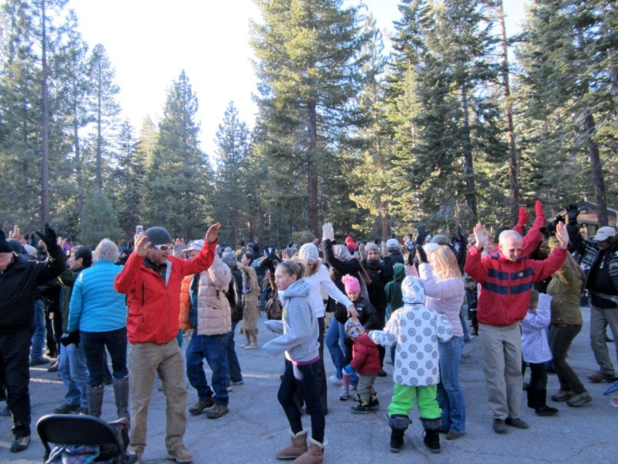 | Carolyn O'Connor / Sierra Sun Eagle Wings concluded with a round dance, inviting the audience to participate in dancing and praying for much-needed snowfall for the mountains and the valleys. These were the tribes that came to pray and dance for snow prior to the 1960 Olympics when snow was lacking. One member in Sunday's group also danced in the 1960 event.
TAHOE/TRUCKEE, Calif. — It's working. Sunday, Native American adults and youth held hands with the public in a traditional “Round Dance” asking for spiritual help to bring snow to the Lake Tahoe region.
This morning, for the first time in two months, a dusting of snow appeared at lake level with two inches at 8,200 feet. According to meteorologists, the storm door is set to open Wednesday with a possible 6 feet of snow falling above 8,000 feet by Monday.
“We were thrilled to wake up to snow on the ground,” said Chief Marketing Officer Andy Chapman of the North Lake Tahoe Resort Association. “It's been a peculiar winter nationwide, but it looks like Mother Nature is finally stepping up and delivering with storms lined up for the next seven days. A big thank you goes out to the 200-plus Native Americans, visitors and community members who danced us into a traditional winter.”
The “Round Dance” held on the West Shore at Ed Z'Berg Sugar Pine Point State Park in Homewood was performed by elaborately dressed Paiute, Shoshone, and Washoe — tribal relatives of the dancers who performed at the 1960 Winter Olympic Games — at the official closing ceremonies of North Lake Tahoe's Olympic Heritage Week. Sugar Pine Point State Park was the summer home of the Washoe people.
In a similar situation more than 50 years ago, an absence of January snow in the Sierra posed similar planning concerns for the managers of the 1960 Winter Olympic Games' Nordic events, which were to be held at the same location, Sugar Pine Point State Park. The nervous organizers of those original Olympics brought in Great Basin dancers to encourage snowfall, and history has indeed repeated itself.
Olympic Heritage Week is an annual event in North Lake Tahoe that celebrates the cross-country events (held on the West Shore) during the 1960 Winter Olympic Games. The week's events included appearances by past Olympians, full moon hikes, dinners and fundraisers, as well as the opportunity to take part in guided cross-country skiing adventures along the recently restored Olympic trails.
For more information about North Lake Tahoe ski resorts, the best deals on lodging, special events, dining and winter activities, click to www.GoTahoeNorth.com.
http://www.sierrasun.com/article/20120116/COMMUNITY/120119931
— Submitted to aedgett@sierrasun.com

BULLITIN from other U.S. regions plus Canada!

TELLURIDE’S UTE MT GRATITUDE SNOWDANCE – January 28th
In solidarity with 11 other ski areas,
many finally got snowblessings, and Colorado the most
On January 28, Ute Mt Ute Elder Reggie Lopez, a skier, graciously offered and led a “Gratitude Snowdance” in Telluride’s Mountain Village for all these snowblessings from Mother Earth and Creator. Telluride received the most snow in Colorado this season without a snowdance, chalk it up to the good karma from pioneering their on-going “Ute Mt Future Olympians Ski and Snowboard program” in 1996, which snowballed across North America. Not to mention the daily thanksgiving prayers of Ute Elders.
Reggie’s snowdance ended with a touching friendship circle dance with their royalty, a tiny tot, and 75 Telluride locals and visitors to the drums and songs of Catching Eagle.
He shared how "we were joined by eight skiers and boarders from Canada's First Nations Cree of Saskatchewan. One said, 'Holy Cow,' when he heard the drums from the restaurant. They thought they were hearing things, like the Winter Spirits were singing." After Reggie also made a tobacco offering on the peak, sixteen Ute Mt kids and chaperones then got to enjoy the snow they helped inspire, dancing down their beloved ancestral mountains.
TelSki’s GM Dave Riley also wanted to give appreciation for the snowstorms from the other snowdances. Through the tribes we skiers have learned that Mother Earth responds to gratitude even more generously than we do. For example, at their annual Gratitude Snowdance on closing weekend (like many ski areas) last April, which Riley and TelSki owner Chuck Horning participated in, slushy conditions were transformed into powder. WSJ reported that at the end of Vail’s snowdance, “Mr. Box presented Mr. Chris Jarnot, the COO, with a package of tobacco and asked that he find a special place on the mountain and sprinkle it in all four directions.”
SOLIDARITY SNOWDANCE WITH 11 SKI AREAS
At high noon on the 28th, Elders and/or locals at 11 other ski areas joined in solidarity with Telluride’s ceremony, with gratitude prayers for their wonderful snow, or any precious snow. They included Sun Valley, Wintergreen (VA), Sandia (NM), Mt. Baldy (CA), Mt. Abram (Maine), Mt Creek (NJ), Spirit Mt (Wisc), Cochran Hill, Vt, Squaw Valley, Steamboat, and the Arizona Snowbowl. Most bave since received snow!
PACIFIC NORTHWEST RECEIVES UP TO 10 FEET OF SNOW!
Reggie explained that many of the tribes North of Colorado into Canada - like the Ute and Shoshone sister tribes – have had a long tradition of Winter Round Dances or Moon Dances, often all night long, which assist Nature with moisture. The snowmelt is critical for LIFE: Nature, food, our water supply, and fire prevention.
He said, “Most of these tribes sing the same songs this time of year, thanking Creator for the life-giving snows, which often results in more snows. That includes my relatives in the Pacific Northwest from the Shoshone, Warm Springs and Tulalips tribes.”
That explains the wonderful snows in Washington and Oregon in January, thanks also to their most generous Native Ski programs, led by John Gifford, President of Ski Washington and Stevens Pass.
“In giving 20 season’s passes a year to the Tulilips and Lummis, they have 60 happy healthy youth participating in their programs. Some were neglected and therefore rough rez kids who are now drug-free - and eight now compete on the USASA circuit. We raised $15,000 to buy 40 more passes, and other tribes want programs,” said Sandra Wagner, director of the Tulalip Snowboard Program. The seeds were planted when our Native American Olympic Team Foundation orchestrated two snowdances at the Seattle Ski Shows and a televised ceremonial launching of a Puyallup-Tulalip Native program at Snoqualmie.
“Our Mt Hood Meadows has a Warm Springs Ski & Snowboard program as well as a jobs program. We also invite them to use our chairlifts in their berry picking season,” said Dave Tragethon, director of communications. No wonder Mt Hood received the most snow in America in January, 10 feet!
MIDWEST GETS A DUSTING
I asked Reggie if the Anashenabe/Chippewa/Ojibwe around Minneapolis also have some similar traditional dances, and he said yes, which could also explain their recent snows. All these examples may explain why the Western ski areas have better snow than the Midwest and Eastern ski areas. They Western ones are a little more big hearted in inviting their tribal youth back to their ancestral mountains to ski, snowboard and share these snowdances.
EAST GETS SNOWS
The Vermont Abenaki, where I’m from, led by my friend Chief Nancy Millette, have saved our ski areas a handful of times, including at our Olympic Reunion Antique Race at Mt Ascutney, covering their grassy slopes with snow. Bill Henne and his staff participated in the snow ceremoniy and it snow exactly one hour later as Chief Nancy said – so she had a chance to get home safely. Chief Nancy was inspired by the Olympians standing up for their cultural rights, the wonderful Cochran family of Olympians hosting an Abenaki program at Cochran Hill, Billy Kidd (Abenki) helping Native Olympic hopefuls, plus Jay Peak and Pico have also hosted their youth. My first coach, Joe Jones, who put five of us Rutlanders on the road to the Olympics, turned out to be Abenaki!
Hopefully the amazing news inspires the Eastern and Midwestern ski areas to get on the bandwagon! Mt Abram and Sugarloaf in Maine, which has a model Penobscot ski program, are planning snowdances with their spiritual leader John Neptune.
The NY Iroquois have similar winter dances according to renowned Mohawk Elder Tom Porter, whose daughter liked snowboarding. So we are exploring bringing a snow dance to Mt Creek (NJ) in appreciation for all Gene Mulvihill, the owner, has done to help us make a lot of this progress for humanity possible.
CANADA HAS GREAT SNOW!
At Vail in 2004, we inspired Canadian Olympic downhiller turned Whistler Director, Steve Podborski, to assist his First Nations. He helped Erin Marchant (Squaminsh), get a $3 million dollar grant from the BC Government to develop FNsnowboarders for their Vancouver Olympics. Extremely popular, it spread to 13 Canadian ski areas. (The grant was from their government as part of healing their First Nations from the rampant boarding school abuses similar to Native Americans. The joy of sports has been found to help heal and restore self-esteem.)
Marchant then assisted the Washington’s Tulalips with their brilliant recreation-competition model, and the FNriders hosts joint training camps at Sun Peaks Canada. Looks like the good karma of Canada for sharing the joy riding down their ancestral mountains has blessed Canada with snow great snow this season!

More Background…

Why the U.N. wants us to spread this snowdance phenomenal to communities worldwide
Dec 8, 2011 reprinted by SIA Journal of Suzy Chaffee’s eNewsChannels column

Indigenous Elders Input Key to Restoring Earth at UN’s RIO+20
Fri, 25 Nov 2011 13:43:35 -0500 EST | No Comments
by Suzy Chaffee
eNewsChannels COLUMN: On November 1, our Native American Olympic Team Foundation (NAOTF) submitted to the UN its recommendations, including wisdom of Indigenous Elders, for the 2012 Rio+20 Conference, June 21-22. This marks 20 years after the first UN Conference on Sustainable Development, and never in history has there been such a need to work in unity to restore Earth.
What gives humanity great hope is our new heart and mindset thanks to the Occupy World Movement, where the 99% are taking more active roles in protecting and sharing the planet’s precious resources. This follows the UN’s “International Mother Earth Day” where 192 Nation States now honor Mother Earth annually on April 22st, for being a living, loving, intelligent, compassionate being. It was initiated by the Indigenous Bolivians after losing in 2008 their 18,000 foot ski area and glacier, the water supply for 2 million people.
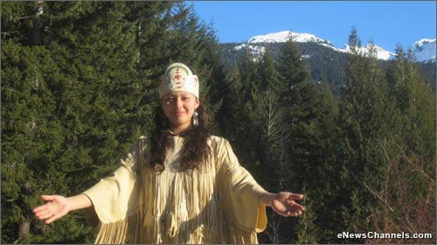
Native American Olympic Cross Country Hopeful, Mariah Cooper, (Lac Courte Oreilles-Oneida) “Honor the Earth Princess,” blissfully blessing Whistler Mt’s XC trails and Nature during the 2010 Vancouver Olympics, to the delight of fellow skiers. Photo courtesy: Karl Schiebe.

For this 2012 summit, the most respected environmental organizations on Earth just submitted their recommendations so that World leaders and citizens could digest their brilliant solutions. Then at RIO+20 they can agree, prioritize and start holistically preventing the projected massive die outs by creating a sustainable New Earth. Many solutions can be implemented now, as time is so precious.
NAOTF’s recommendations are particularly important to the Olympic Sports movement since the world’s mountain chains, with thousands of ski areas on them, are our main source of precipitation (along with the oceans), including the recent freaky weather. And the snowmelt is critical for all our playgrounds and life support systems.
Oprah’s attendance at an Aborigine Women’s ceremony on Australia’s sacred Mt Uluru on world TV was the first time many have been aware of the importance of participating in cross-cultural ceremonies and prayers together. Yet for years many enlightened ski communities in the Americas, Europe, Asia, and elsewhere, have been helping ensure that our beloved snowsports go on through tribal outreach. Disruption of electricity alone from these earth changes that the Mayans and other tribes prophesied, along with increased solar flares in 2012, which NASA warned about – why we need off-the-grid renewable energy – could affect the ability of our civilization to thrive, especially snowsports.
I honor the foresight of my fellow US Olympic Teammates who voted our foundation funding in 1999, realizing that the wisest way to help ensure that future generations can enjoy snowsports is through restoring our integrity with Nature. And what better way than through the tribal wisdom of our ancient ancestors, which the tribes are helping us remember.
Because scientists expect more droughts,(and wildfires that further heat our planet), UN’s Sustainability officer, Marie Mercedes Sanchez, encouraged NAOTF to share with communities around the world how the North American Ski Areas and Tribes have together miraculously ended droughts since 1963. The key is inviting tribal youth to enjoy skiing and snowboarding in their beloved ancestral mountains, which has inspired their Elders to lead Gratitude Snowdances. (See press documented miracles on http://snow-riders.org/mir.html)

Sincere prayers and ceremonies lift the vibration of the mountains, as well as oceans, where no toxins exist, as Japan’s Dr. Emoto has demonstrated, and this purification rebalances Nature’s cycles. Six Nobel Prize winners agree with the gifted Elders and Earth healers, that rebalancing Nature cycles in practical and spiritual ways is crucial to smoothing out these Earth changes.
WORLD INDIGENOUS OUTREACH
Therefore, with the blessings and connections of David Ingimie, President of the SnowSports Industries of America, NAOTF is calling on ALL world ski communities to assist their ski areas in inviting a dozen nearby Indigenous youth for a day of joyful skiing and snowboarding. Plus requesting that an Indigenous Elder or shaman lead a Gratitude Snowdance, and graciously hosting their family. The ideal time for these modest gatherings of good-hearted people from both cultures is this December when ski areas also need ‘gentle snows’ the most, to lead into 2012. This is also a good time for ski areas downunder to thank Creator for the snow they have just received and gather good karma for next season. WWW.SNOW-RIDERS.ORG has maps, websites and contacts to the tribes and ski areas nearest you.
If the tribal youth fall in love with healthy skiing or boarding, which some of their ancestors invented with the Chinese-Mongolians 8-10,000 years ago (according to Mammoth’s 2009 World Ski Congress), we recommend adopting Telluride SkiCo’s Ute Mountain model, endorsed by President Ingimie. Ute students pay (a super affordable) $15./day and chaperones $30.; the ski school donates a few lessons; and a couple of ski shops share donating the rentals as their part of still inspiring snowblessings.
Ski communities could follow New Zealand’s lead. A promoter wants a group of our Native American Olympic Hopefuls, dancers and an Elder to enjoy skiing, boarding and sharing ceremonies with their Maoris and mainstream kids during their June 2012 Winter Festival. Seneca Iroquois Elder RobertJohn Knapp has offered to assist. With citizens from six European countries behind him, Knapp inspired Pope Benedict to declare in 2008 that “it a sin to poison the water.” We are also open to ski and ceremonial exchanges like we did with the 10-year-old King of Africa’s Uganda, (which has snowy mountains) and the Ute Tribe at Colorado’s Keystone Ski Area. For questions, contact suzynativevoices@aol.com
Trendsetting North American Ski areas, including Vail, Telluride, Aspen, Steamboat, Ski Sunlight, Park City’s 2002 Games, Mammoth, Taos, Heavenly Valley, Big Bear, Snow Valley, Snow Summit, Mt Shasta, Mt Ashland, Stevens Pass, Snoqualmie, Alyeska, Cochran’s Hill (Vt), Sugarloaf, Whistler at Vancouver Olympics, Sun Peaks and 11 other Canadian Ski Areas, plus Gstaad (Switz), Kitzbuhl (Austria), Bariloche (Argentina), and Portillo (Chile) have learned priceless lessons from their tribal weather miracles about living in more harmony with Nature: How giving appreciation to Mother Earth for all She has given us, including the snow, plus healing the past and starting a new beginning with nearby tribes through these events and programs, inspires more snowblessings. Also key is switching to earth-honoring green products, organic food, and renewable energy, like Aspen and Jiminy Peak (MA), which are partially self-sufficient solar and wind energy heroes.
In 2007 we skiers learned that prayers can effectively be directed to assist other countries, when European Ski Areas were suffering “the warmest winter in 1,200 years.” NAOTF’s European advisor, French Princess Caroline Murat, reported how the snows finally came following a Hawaiian Elder’s-led prayer, on Feb 14th, Valentine’s Day, to include Mother Earth in our hearts. Participants included many from Earth Charter USA’s 2,500 communities, the ONEness Network, thanks to Oneness scientist Sperry Andrews, and the Pacific Rim thanks to the China Millennium Council.
We also learned from gifted Cherokee Earth healer, Olivia Ellis Phd, the power of praying on the amazing “19 Holy Mountains” on four Continents. “It is like having 3,000 friends praying with you,” she said. Uniting the powerful prayers of an Interfaith Gathering on Mt Baldy Ski Area, a Holy Mt near LA, with millions of Apache-led prayers, helped miraculously bring the rains and wind that stopped the fires across the street from Los Alamos Nuclear Lab.
Scientists have proven the power of prayers and a few have done successful experiments capturing and sending prayer energy. The most effective has been the late Sir George King, a British astrophysicist-mystic who founded the Aetherius Society. He became a household name in the Isles in the 60′s after inventing a way to store in batteries the high vibrational energy of groups chanting and praying on holy mountains, and later redirecting them toward preventing or reducing catastrophes. When the focused energy is released, firestorms, hurricanes, droughts, floods, and earthquakes are neutralized or transformed into life saving weather conditions; work they have been doing for five decades for world communities and Nature. Since it is hard to amass people on a holy mountain or even a prayer group or ceremony at a moment’s notice, King compassionately created this safety net for humanity in advance of extreme weather and earth changes, which we are especially witnessing at this time.
“The tribes call this ‘The Purification.’ Ultimately it’s not Mother Earth, but us who need to raise our vibration by green actions, healing deeds and appreciation–so She doesn’t have to by shaking us off Her back. Our Earth Mother will be purified one way or another, with or without us. The karmic bell that is tolling now tolls to let us know it is time for all hands to be on deck working together; the only other option is to walk the plank,” said Dr. Ellis.
Here’s an example of the beautiful energy at the Mt Baldy Pilgrimage; http://sites.google.com/site/worldpeacepilgrimage/ Locations of Holy Mts – near Aspen plus New Hampshire, Britain, Switzerland, France, Africa - and info to make safe pilgrimages on Aetherius.org.
Since not everyone has mountains, and we must together restore our dying oceans to survive and thrive, the UN also encouraged us to spread the importance of community participation in oceandances, led by Indigenous Elders or shamen. For example, I attended a joyful Azteca-led one in Puerto Vallarta, Mexico, on 11/11/11, a holy day that also multiplies prayers. Regular tribal ceremonies have helped keep ports like Puerto Vallarta, Paradise. Their waters are clear and the whales are jumpin!
A Mayan leader said this cross-cultural reuniting of our hearts with Mother Earth through ceremonies, is the key to reducing the 2012 earth changes. Why not open our hearts a little now instead of after catastrophes? Sir George King reinforced the Mayan message in saying that there is only one energy crisis on this planet, and it is a spiritual energy crisis.
Each culture has a special critical gift for humanity. The Indigenous Peoples have the closest connection with Mother Earth and track record of reviving and rebalancing Her, praised by UN members. With 2,000 tribes going extinct each year, according to the U.N., this outreach will help preserve them and their priceless wisdom that we need more than ever. Therefore we hope that many are inspired to read and act on NAOTF’s holistic recommendations for RIO+20, including why we need a nuclear-free world to together restore our only home. http://www.uncsd2012.org/rio20/index.php?page=view&type=510&nr=637&menu=20
YOUTH CARETAKERS
Since the youth are the future, we call on the world schools to share the following stunningly riveting youtube videos to save us all precious time helping create a generation of Earth Caretaking Geniuses:
A Child’s Appeal to the U.N.: http://www.youtube.com/watch?v=7KY9LaxVkDM
Plus the multi-lingual “HOME,” “Water: The Great Mystery”, the “UN’s 2011 International Year of Forests.” http://www.karmatube.org/videos.php?id=2387,
Austrian astrophysicist-shaman Johann Grander discovered a way to use the original water with its potent healing properties to purify tap water. Using it in the snowmaking machines of his country’s ski areas has resulted in more consistent snow and people can even drink out of their Kitzbuhl streams. His Grander Method, honored by the Russians, has amazing applications used worldwide, such as replacing chlorine in pools: http://usa.grander.biz/en/johann-grander.
Michael Berry, President of the National Ski Areas Association, has praised the Mountainriders Alliance (MRA), founded by Jamie Schectman, for helping create a new era of U.S. ski areas putting communities, green energy and integrity with Nature, including tribal ceremonies and programs, over profits. (mountainridersalliance.com) MRA just announced partnering with Skilogik, a green equipment pioneer. For every pair of their magnificent cutting edge skis sold, they plant a tree and donate $35 to give Native youth a chance to restore their health and have Olympic dreams. http://www.powdermag.com/latest-news/mountain-riders-alliance-skilogik-partner-on-custom-skis/
Other key videos are: Lester Brown’s “Planet’s Scarcest Resource Is Time”: http://www.organicconsumers.org/articles/article_22858.cfm and THRIVE: What On Earth Will It Take? http://www.youtube.com/watch?v=OibqdwHyZxk
Here’s how school diets can transform violence and student bullies into harmonious Earth Caretakers, why First Lady Michelle’s Children’s Organic Garden at the White House is spreading to schools across the U.S., since it is also helps end obesity. http://www.wanttoknow.info/050520schooldietchange
NAOTF recommends Stevia, a no carb South American Tribal-discovered herbal sweetener, which has also been helping Asians stay lean and clean and lower diabetes and alcoholism, since alcohol is a toxic sugar. Fortunately, Stevia sweeteners and beverages have just been approved in the US and E.U..
Telluride’s 4th grade environmental class got to see Nature through the eyes of their Indigenous ancestors when a Park Ranger got sick and we helped them get a Cherokee historian to take the students on a hike. The kids were totally fascinated and wanted more. Inspired by their consistent snow, Aspen SkiCo wants to include Ute-led Nature hikes.
By world schools and ski areas including Native-led hikes, humanity could have a spiritual love affair with Nature, like most of the UN members and renowned authors who spoke on this year’s Live webcast part of International Mother Earth Day.
Here are the other priceless recommendations for RIO+20 by each country’s most effective environmental organizations: http://www.uncsd2012.org/rio20/index.php?menu=115
Special thanks to Mountain Creek Ski Resort (NJ) and Ute Mt Casino (CO) for helping make all this possible. And Thanksgiving blessings to all Mother Earth’s caretakers, especially Native Americans, whose Iroquois model of male-female balanced democracy is springing up worldwide.
The Elders and your children bless you for doing your part to create this dawn of a joyfully humming New Earth!
###
Contact; suzynativevoices@aol.com

About Suzy Chaffee
Suzy Chaffee was captain of the US Team at the '68 Grenoble Olympics. As a child ballerina she then helped invent ski ballet to become World Freestyle Champion and star in Bogner's world hit "Fire & Ice." As the first woman on the USOC board she united world athletes to reform the Olympic rules; led the Title 1X March for Equal Opportunities for women in school sports; and is ski teacher for Presidents, corporations and Native youth.
After witnessing four weather miracles in 1995, after teaching a Lakota named Rollingbears to ski with a lift ticket donated by Telluride SkiCo, Chaffee co-founded the Native Voices Foundation in 1996, now called the Native American Olympic Team Foundation (NAOTF), which has inspired ski areas across North America to invite thousands of tribal youth back to their ancestral lands to ski and snowboard. That inspired their Elders to lead Gratitude Snowdances that have saved ski resorts from priceless droughts. Along with fellow Olympian, Steamboat’s Billy Kidd, they are giving tribal youth a chance at the 2012 London and 2014 Russian Olympics.

SPECIAL THANKS to Gene Mulvihill at NJ’s Mt Creek Ski Resort, Ute Mt. Casino, SkiLogic and all those over the years who have helped make this joyous snow bridge between the cultures possible. NAOTF needs help to be able to truly spread this snowdance phenomena, as well as oceandances, to communities around the world for the UN and humanity to smooth the earth changes as we transcend into a glorious new era. NAOTF.org.

